**SETTING UP INFLUXDB AND PERFORMING OPERATIONS ON THE SAME**

**(IN UBUNTU)**

__________________________________________________________________

1. Download and install Influxdb for ubuntu by running the following commands in terminal.

wget <https://dl.influxdata.com/influxdb/releases/influxdb_1.7.6_amd64.deb>

sudo dpkg -i influxdb_1.7.6_amd64.deb

1. To start influxdb, enter the following command in the terminal.

sudo service influxdb start

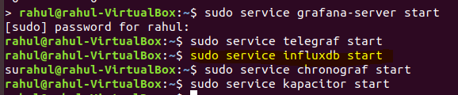

1. To view or use the data, start influx using the aforementioned command.

Then enter the following commands:

Influx

show databases

use telegraf

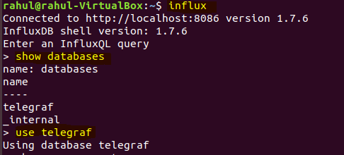

Show measurements

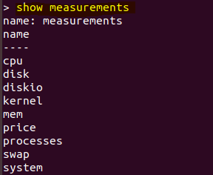

select* from <measurement> limit <integer_value>

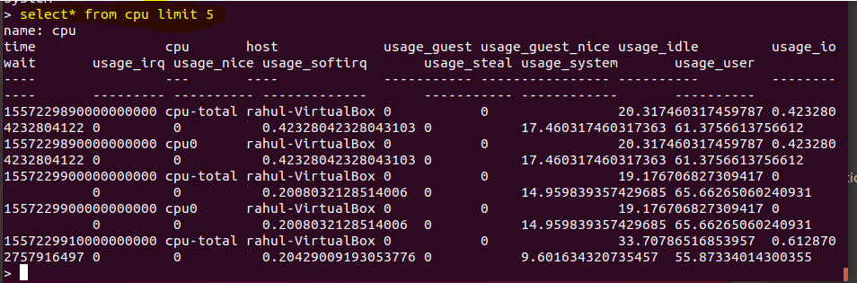

1. To display the time in the databases in Human Readable Form enter the following commands:

Influx -precision rfc3339

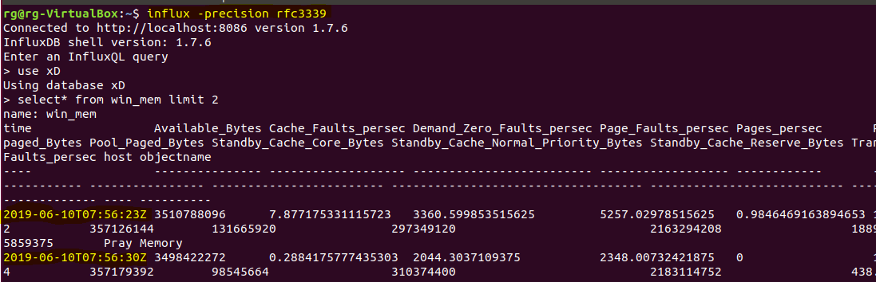

**OR**

Influx

precision rfc3339

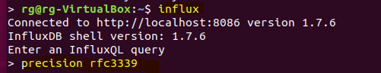

1. In order to Create or Delete a database use the following commands:

Create database <database name>

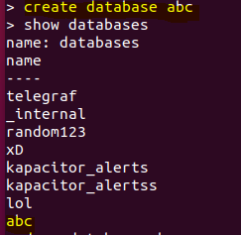

Drop database <database name>

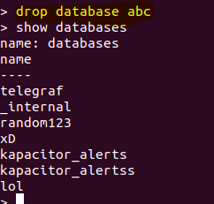

1. In order to download the contents of a database as a CSV file, use the following command:

Influx -database ‘database_name’ -execute ‘select* from table_name’ -format csv > test.csv

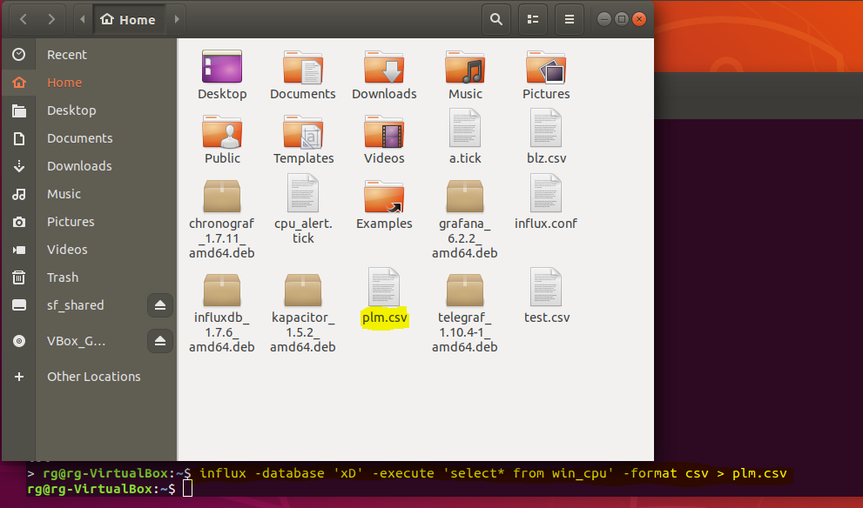

1. In order to directly enter data in a database in influxdb, follow the following commands:

Influx

Use <database_name>

Insert <table_name>,<attribute_name>=value <attribute_name>=value <unix_time>

